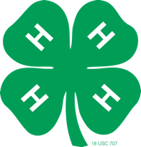
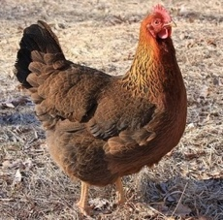
2023 Martin County 4-H Poultry Chain

Laying Hen Show, Poultry Showmanship and Open Chicken and Rooster Show

October 10, 2023

The Martin County 4-H Poultry Chain is right around the corner! The 2022 Martin County 4-H Poultry Chain will take place October 10, 2023 at the Martin County Farmers Market. Birds will be dropped off between 7:30 a.m. and 9:00 a.m. to have their blood tests by NCDA and be judged. Birds being shown this year for the pen of three are Golden Comets.

In addition to our pen of 3 class, we will be having our Open Show class of Hens and Roosters again this year. These classes are open to any youth ages 5-18 (as of 1/1/23). Classes will begin at 4:00 pm. All birds will go back home with owners.

The Martin County 4-H Poultry Chain and Show is going to be a wonderful event this year! For more information, please contact Joy Pierce at 252-789-4370 or joy_pierce@ncsu.edu.

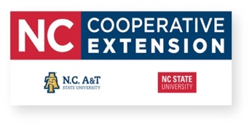

Schedule of Events

7:30 a.m.- 9:00 a.m.: All poultry must be dropped off at the Martin County Farmers Market

10:00 a.m.: NCDA Poultry Testing begins

2:30 p.m. – 3:30 p.m.: Birds will be judged (Pen of three birds)

3:45 p.m.: Youth need to be at Farmers Market

4:00 p.m.: Youth poultry Showmanship Contest will take place

4:15 p.m.: Open Show Hen and Rooster Class will take place

4:30 p.m.: Award Ceremony

