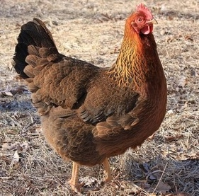

2019 Martin County 4-H Poultry Chain

Laying Hen Show, Poultry Showmanship, Open Chicken and Rooster Show, and Auction Sale

October 8, 2019

The Martin County 4-H Poultry Chain is right around the corner! The 2019 Martin County 4-H Poultry Chain will take place October 8, 2019 at the Martin County Farmers Market. Birds will be dropped off between 7:30 a.m. and 9:00 a.m. to have their blood tests by NCDA and be judged. Birds being shown this year for the pen of three are Welsummer Laying Hens.

We will have a new addition to our show this year. At 4:00 p.m., we will have our Open Show class of Laying Hens and Roosters. Youth will compete in showing their open show laying hen or rooster. Our awards program will take place at 4:15 p.m. and the auction sale will begin at 4:30 p.m. All proceeds from the auction will go directly to the youth participants.

The Martin County 4-H Poultry Chain and Show is going to be a wonderful event this year! This annual event is also part of our 2019 National 4-H Week event schedule. For more information, please contact Kyndle Nichols, Martin County 4-H Youth Development Agent at 252-789-4370 or via e-mail at kcnicho3@ncsu.edu.
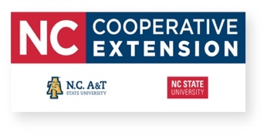

Schedule of Events

7:30 a.m.- 9:00 a.m.: All poultry must be dropped off at the Martin County Farmers Market

10:00 a.m.: NCDA Poultry Testing begins

11:30 a.m.- 2:00 p.m.: Birds will be judged (Pen of three birds)

3:40 p.m.: Youth poultry Showmanship Contest will take place

4:00 p.m.: Open Show Laying Hens and Roosters Showmanship Contest will take place

4:15 p.m.: Laying hens, open class, and showmanship winners announced during awards ceremony

4:30 p.m.: Auction Sale (Pen of three birds ONLY)

