2019 Martin County 4-H Poultry Chain Show

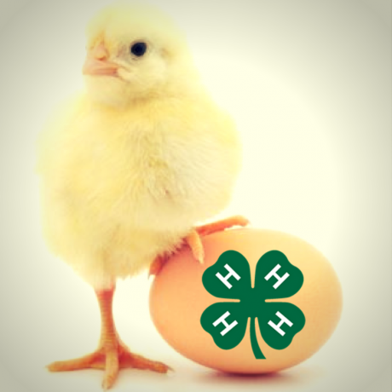

Hello Everyone, we are excited for the 2019 Martin County 4-H Poultry Chain Show and Sale! Below you will find some important information pertaining to this event. If you have any questions or need anything before the show, please feel free to contact Kyndle Nichols, Martin County 4-H Youth Development Agent.

This year, the poultry chain will be on Tuesday, October 8, 2019 at the Martin County Farmers Market. Birds need to be dropped off between 7:30 a.m. and 9:00 a.m. Participants will need to bring their best three hens for showing, along with cage and feeders/waterers. The birds need to be alike in type and kind. During the time the birds are at the Farmers Market, the North Carolina Department of Agriculture poultry specialist will be coming to do blood tests on all birds. This is a requirement for all poultry shows in North Carolina. The birds will also be judged during the day.

Participants will need to return to the Martin County Farmers Market by 3:30 p.m. for our Poultry Showmanship Show. Participants will show one of their birds for the showmanship class. Showmanship classes will be divided into Cloverbud, Junior, and Senior age division.
Participants will be getting money from their birds through the auction this year. In order for participants to receive their money from the auction, record books must be completed on their project. Participants will not receive their checks until their record books are turned in. If record books are not turned in within 30 days, checks will be forfeited.

Record book forms will be provided to participants at the Poultry Chain Show on October 8, 2019. You will be required to write a thank you letter to the buyer of your chickens. This will be turned in with your record book.

Pen of three chickens will be sold amount per bird. Buyers of birds DO NOT have to take possession of the birds. IF YOU DO NOT WANT A BUYER TO TAKE POSSESSION OF YOUR BIRDS, AND YOU WANT TO TAKE THEM HOME, YOU MUST LET THE EXTENSION STAFF KNOW DURNING DROPOFF. A list of potential buyers for the 2019 Martin County 4-H Poultry Chain Show and Sale will be sent out. Please write to any potential buyers, you would like to invite to come out to our show.

We have a new addition to our poultry chain this year! We will be offering an open class for chickens and roosters. All participants are encouraged to participate in the Open Chicken Show. Rules for the Open Chicken Show will follow this letter. Please call the office if you are interested in participating in the Open Chicken Show.

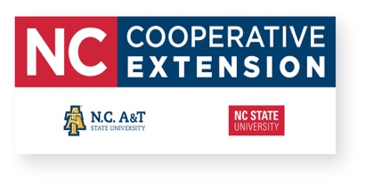
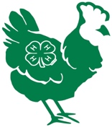
If you have any questions feel free to contact Kyndle Nichols, by telephone at 252-789-4370 or by e-mail kcnicho3@ncsu.edu.

