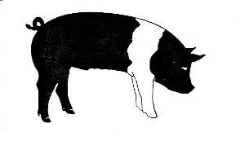***Martin County 4-H Market Hog Records***



Name:_____________________________________

Address:______________________________________________

City:___________________ State:______ Zip Code:___________

Years in 4-H:________

Parent’s or Guardian’s Signature:_____________________________

Martin County 4-H Agent’s Signature:_________________________

**Production Information**

While completing your market goat 4-H project, you were able to learn information about management practices of swine husbandry. In the space provided please explain how identification (tattoo, ear tag, etc.) disease control (vaccinations or treatments), external parasite control (live and mange), internal parasite control (de-worming), facilities and equipment (pen, shelter, fitting equipment, etc.), waste disposal (handling manure cleaning), and any other management practices you did while raising your animal(s).

**________________________________________________________________________________________________________________________________________________________________________________________________________________________________________________________________________________________________________________________________________________________________________________________________________________________________________________________________________________________________________________________________________________________**

