***Martin County 4-H***

***Cloverbud Market Lamb Project Record Book***



Name:_____________________________________

Address:______________________________________________

City:___________________ State:______ Zip Code:___________

Years in 4-H:________

Parent’s or Guardian’s Signature:_____________________________

Martin County 4-H Agent’s Signature:_________________________

***Market Lamb 4-H Records***

My lamb’s name:______________________

My lamb’s ear tag:_____________________

Breed of lamb:________________________

Date Project Began:________________________

Date Project Ended:_________________________

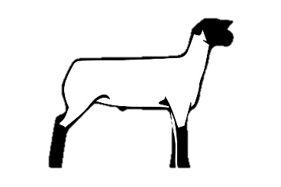

**Feed Records**

As part of your market lamb project, you have learned many new things about how to feed your lamb. Please list the date, kind of feed, how many pounds of feed, and how much your feed cost below. At the end of the chart, add everything together to find your total feed bill.

|  |  |  |  |
| --- | --- | --- | --- |
| **Date** | **Kind of Feed** | **Pounds Bought** | **Cost** |
| Ex: 2/1/2016 | Lamb Feed | 50 pounds | $15.00 |
|  |  |  |  |
|  |  |  |  |
|  |  |  |  |
|  |  |  |  |
|  |  |  |  |
|  |  |  |  |
|  |  |  |  |
|  |  |  | **Total:** |

**Additional Expenses**

As you have learned, sometimes when we raise animals we have extra expenses other than feeding. Please list any expenses other than feed that you had during your project. Ex: Pen building materials, veterinary expenses, internal/external parasite control, etc.

|  |  |  |
| --- | --- | --- |
| **Date** | **Kind of Expenses** | **Cost** |
|  |  |  |
|  |  |  |
|  |  |  |
|  |  | **Total:** |

**Final Records**

Final weight of lamb _______________

Starting weight of lamb _______________

Total cost of lamb _______________

(when bought)

Total Feed Cost _______________

Total Additional Expenses Cost _______________

Income from the Martin County 4-H _______________

Livestock Show & Sale

Total Profit _______________

(Income – total cost of lamb – total feed cost –

total additional expense cost)

**Project Story**

In the space provide please write a short story about your project. Tell about how much fun you had, what you learned, how you cared for your lamb, etc.

____________________________________________________________________________________________________________________________________________________________________________________________________________________________________________________________________________________________________________________________________________________________________________________________________________________________________________________________________________________________________________________________________________________________________________________________________________________________________________________________________________________________________________________________________________________________________________________________________________________________________________________________________

**Project Scrapbook**

Create a scrapbook with pictures taken during your Market Lamb 4-H Project. Your scrapbook can be up to 4 pages long. Please attach your scrapbook with your record book. You can use computer paper, construction paper, etc. to serve as a background page for your pictures.

**Project Fun Activities**

On the following pages you will find several fun activities for you to complete. These activities will teach you more about your market lamb project and help you to grow as a 4-H’er.

